

**SG2002**

EVB Hardware Guide

Version: 2.0

Release date: 2023-12-13

© 2023 Sophgo

Revision History

|  |  |  |  |
| --- | --- | --- | --- |
| **Revision** | **Date** | **Author** | **Description** |
| 0.1 | 2022/04/27 | Miller.zhang | Initial |
| 1.0 | 2022/09/13 | Miller.zhang | Update |
| 2.0 | 2023/12/13 | zishuo.wang |  |
|  |  |  |  |
|  |  |  |  |
|  |  |  |  |
|  |  |  |  |
|  |  |  |  |
|  |  |  |  |

Contents

Revision History 2

Contents 3

1 Preface 4

1.1 Overview 4

1.2 Product Version 4

1.3 Readership 4

1.4 Revision History 4

2 Overview 5

2.1 Introduction 5

2.2 Product Accessory List 5

2.3 Related Components 5

3 Hardware Introduction 6

3.1 Interfaces and Peripheral Hardware 6

3.2 GPIO Configuration 7

4 Operation Guide 10

4.1 caveat 10

4.2 HW Config (Boot device selection) 12

4.2.1 MIPI Related IO to JTAG I2C Resistors 13

4.3 SD Card Power Enable Polarity Switching 13

4.4 VDDQ Voltage Switching 14

4.5 Refer to the Jumper Connection 14

# Preface

## Overview

Introduction to the SG2002 EVB development board features, hardware characteristics, and peripheral hardware interface configurations.

## Product Version

The EVB development board versions corresponding to this document are listed below.

| Product Name | | Product Version | |
| --- | --- | --- | --- |
| WEVB-0006A-V01 | |  | |

## Readership

This document (this guide) applies primarily to the following engineers:

* Technical Support Engineer
* Hardware Development Engineer

## Revision History

The revision record accumulates the updated description of each document and the content of the update.

| Revision Date | Releases | Revised Description |
| --- | --- | --- |
| 2022-04-27 | V0.1 | Initial |
| 2022-09-13 | V1.0 | Update |

# Overview

## Introduction

The WEVB-0006A-V01 EVB development board is a validation board developed for the Cvitek SG2002 high-performance AI chip. It is designed to demonstrate the powerful image analysis and computing capabilities of the SG2002 chip, as well as its diverse hardware interfaces. Additionally, it provides customers with a hardware reference design for the SG2002 chip, allowing them to complete the hardware development of their products with minimal modifications.

## Product Accessory List

The list of accessories for WEVB-0006A-V01 EVB development board is as follows:

* WEVB-0006A-V01 EVB Board ×1
* Sensor Board ×1
* AC110V/AC220V to DC12V Transformer
* Support 1.8V/3.3V UART Tool

## Related Components

The following related accessories are not included in the WEVB-0006A-V01 EVB development board package

* Microphone Module
* Wi-Fi module
* Speaker Module
* Panel module

# Hardware Introduction

## Interfaces and Peripheral Hardware

The interface of the WEVB-0006A-V01 EVB board is shown in Figure 3.1.

The interface description of the WEVB-0006A-V01 EVB board is shown in Table 3.1.



Figure 3.1

Pay special attention to the following four configurations with different settings: 13 (JTAG), 15 (I2C), 26 (VDDQ), and 24 (CPU_SEL).

Table 3-1

|  |  |
| --- | --- |
| Number | Description |
| 1 | Panel Slot (TX0) |
| 2 | Sensor Slot (RX1) |
| 3 | Sensor Slot (RX0) **MAIN** |
| 4 | Sensor1 Clk source (can be provided by the main chip or externally for convenient development of other sensors) |
| 5 | Sensor0 Clk source (can be provided by the main chip or externally for convenient development of other sensors) |
| 6 | Audio Out (includes an amplification circuit and can be connected to external speakers) |
| 7 | MIC IN (can directly connect electret microphones or external modules) |
| 8 | AUDIO OUT , MIC IN |
| 9 | Micro SD card slot |
| 10 | HW Config (Boot device select) |
| 11 | HW Config (Boot device select) |
| 12 | UART0 Debug Port (VDDIO_EMMC_SD0, mostly 3.3V) |
| 13 | CRA = SG2002 CA53 JTAG (1.8V)  CRR = SG2002 RISCV JTAG (VDDIO_EMMC_SD0, mostly 3.3V) |
| 14 | DC12V IN |
| 15 | R = I2C0 (1.8V) |
| 16 | SDIO WIFI Module (1.8V) |
| 17 | internal EPHY |
| 18 | Slave Micro USB port (supports 5V power supply) |
| 19 | USB2.0 |
| 20 | Flash socket |
| 21 | AUX0 ground (during fast boot, QFN will be forced to upgrade) |
| 22 | PWR_BUTTON |
| 23 | PWR_RSTN |
| 24 | CPU_SEL (for unsealed ICs) |
| 25 | SD_PWR_EN polarity switching |
| 26 | SG2002 Specialized Power Switching (Unplug for DDR3 1.35V, don't plug it in) |

## GPIO Configuration

|  |  |  |
| --- | --- | --- |
| **BALL** | **Substrate Name** | **EVB Net Name&** |
| **Default Function Description** |
| 7 | SD0_CMD | SD0_CMD |
| 8 | SD0_D0 | SD0_D0 |
| 10 | SD0_D1 | SD0_D1 |
| 11 | SD0_D2 | SD0_D2 |
| 12 | SD0_D3 | SD0_D3 |
| 14 | SD0_CD | SD0_CD |
| 15 | SD0_PWR_EN | SD0_PWR_EN |
| 17 | SPK_EN | LCD_RST/LED_CTL |
| 18 | UART0_TX | UART0_TX |
| 19 | UART0_RX | UART0_RX |
| 20 | EMMC_DAT2 | SPINAND_HOLD |
| 21 | EMMC_CLK | SPINAND_CLK(IO) |
| 22 | EMMC_DAT0 | SPINAND_MOSI(IO)(PHY) |
| 23 | EMMC_DAT3 | SPINAND_WP(IO)(PHY) |
| 24 | EMMC_CMD | SPINAND_MISO(IO)(PHY) |
| 25 | EMMC_DAT1 | SPINAND_CS(IO)(PHY) |
| 26 | JTAG_CPU_TMS | LCD_PWR_CTL |
| 27 | JTAG_CPU_TCK | LCD_PWM |
| 28 | IIC0_SCL | IIC0_SCL(IO1) |
| 29 | IIC0_SDA | IIC0_SDA(IO1) |
| 30 | AUX0 | USB_PT1_EN |
| 40 | PWR_SEQ1 | PWR_SEQ1 |
| 41 | PWR_SEQ2 | PWR_SEQ2 |
| 43 | PWR_WAKEUP0 | PWR_WAKEUP |
| 44 | PWR_BUTTON1 | PWR_BUTTON1 |
| 47 | PWR_GPIO0 | SOC_PORT_SEL |
| 48 | PWR_GPIO1 | SOC_HUB_RESET |
| 49 | PWR_GPIO2 | AMP_MUTE/CHIP_EN |
| 51 | SD1_D3 | SD1_D3 |
| 52 | SD1_D2 | SD1_D2 |
| 53 | SD1_D1 | SD1_D1 |
| 54 | SD1_D0 | SD1_D0 |
| 55 | SD1_CMD | SD1_CMD |
| 56 | SD1_CLK | SD1_CLK |
| 58 | PWM0_BUCK | PWM0_BUCK |
| 59 | ADC1 | VBS_EN |
| 60 | USB_VBUS_DET | USB_VBUS_DET |
| 72 | PAD_MIPIRX4N | MIPIRX1_PAD4N |
| 73 | PAD_MIPIRX4P | MIPIRX1_PAD4P |
| 74 | PAD_MIPIRX3N | MIPIRX1_PAD3N |
| 75 | PAD_MIPIRX3P | MIPIRX1_PAD3P |
| 76 | PAD_MIPIRX2N | MIPIRX0_PAD2N |
| 77 | PAD_MIPIRX2P | MIPIRX0_PAD2P |
| 78 | PAD_MIPIRX1N | MIPIRX0_PAD1N |
| 79 | PAD_MIPIRX1P | MIPIRX0_PAD1P |
| 80 | PAD_MIPIRX0N | MIPIRX0_PAD0N |
| 81 | PAD_MIPIRX0P | MIPIRX0_PAD0P |
| 83 | PAD_MIPI_TXM2 | (PAD_MIPI_TXM2) |
| 84 | PAD_MIPI_TXP2 | (PAD_MIPI_TXP2) |
| 85 | PAD_MIPI_TXM1 | (PAD_MIPI_TXM1) |
| 86 | PAD_MIPI_TXP1 | (PAD_MIPI_TXP1) |
| 87 | PAD_MIPI_TXM0 | (PAD_MIPI_TXM0) |
| 88 | PAD_MIPI_TXP0 | (PAD_MIPI_TXP0) |
| 2 | PAD_AUD_AINL_MIC | PAD_AUD_AINL_MIC |
| 4 | PAD_AUD_AOUTR | PAD_AUD_AOUTR |

# Operation Instructions

## Precautions

1. The WEVB-0006B_V01 EVB development board is intended for laboratory or engineering development environment.
2. Ensure that the power configuration matches the interface voltage levels.
3. The wiring sequence for the UART0 Debug Port (located at J19) is as follows. Pay attention to the correct order (mismatch with screen print) to avoid reversing the connections.

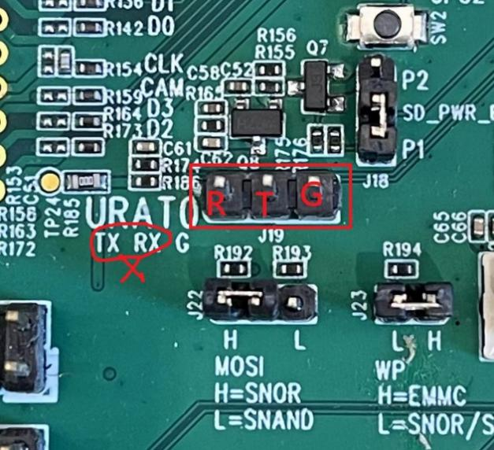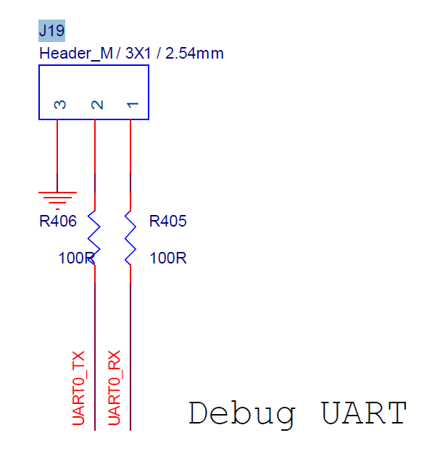

1. Sensor
2. Sensor: The EVB board can only be used for monocular or binocular, a hardware Rework is required for monocular boards to be used for binocular and vice versa.
3. For binocular boards: only support the 0021A (GC2093 + GC2053) and 0022A (GC2093 + GC1054) dual-eye sensor boards.
4. The monocular sensor board is attached to the J3 connector as shown in the figure below:

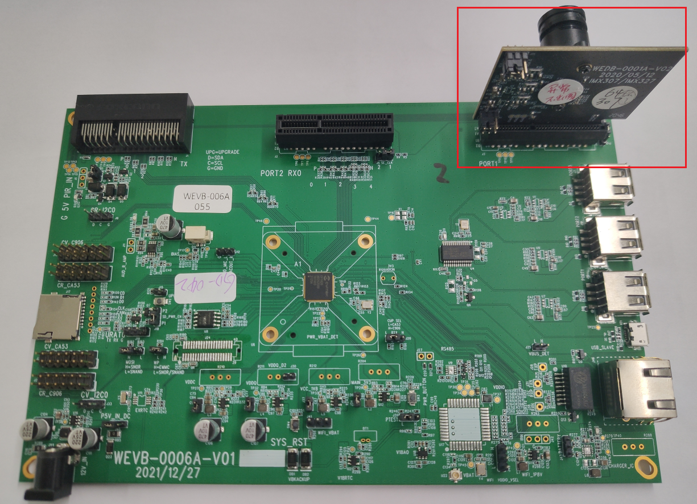

1. Panel

When using a touch screen display, hardware rework is required.

Without a screen, CAM_MCLK and CAM_RST are connected to MIPI_TXP0 and MIPI_TXM0;

When a screen is present, because MIPI_TXP0/M0 is needed for the screen, CAM_MCLK and CAM_RST should be rerouted to SD1_D2 and SD1_D3;

Note: By default, the software assumes a configuration without a screen. If you need to use a touch screen, the software must revert MIPI_TXP0/M0 to its original function as MIPI_TX, and configure the CAM_MCLK and CAM_RST for the sensor to use SD1_D2 and SD1_D3. Otherwise, the screen won’t light up.

## HW Config (Boot Device Selection)

|  |  |  |
| --- | --- | --- |
|  | **J22**  **EMMC_DAT[0]**  **SPINOR_MOSI**  **SPINAND_MOSI**  **Default pull up** | **J23**  **EMMC_DAT[3]**  **SPINOR_WP_X**  **SPINAND_WP_X**  **Default pull up** |
| Boot from EMMC | Pull up (NC/Jump 1-2 High) | Pull up (NC) |
| Boot from SNOR | Pull up (NC/Jump 1-2 High) | Pull down (Jump 1-2 Low) |
| Boot from SNAND | Pull down (Jump 2-3 Low) | Pull down (Jump 1-2 Low) |

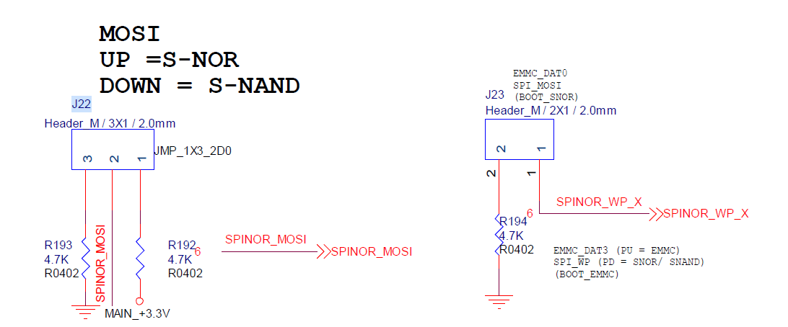

When using the Flash socket, you can use the PU/PD resistor on the daughter board.  
 It is recommended to leave the EVB boot device config jumper unplugged.

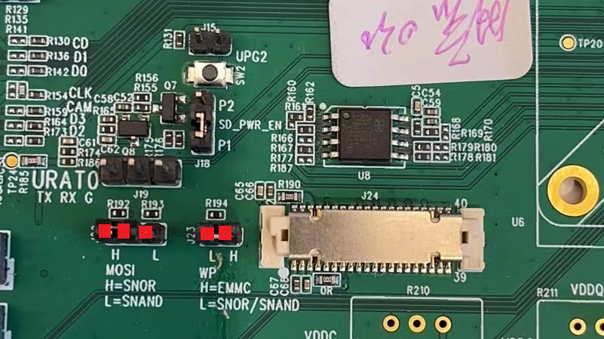

### MIPI Related IO to JTAG I2C Resistors

If you intend to use SG2002 (I2C0), some resistors need to be modified for the SG2002 (CA53 JTAG) located in the top-left corner.

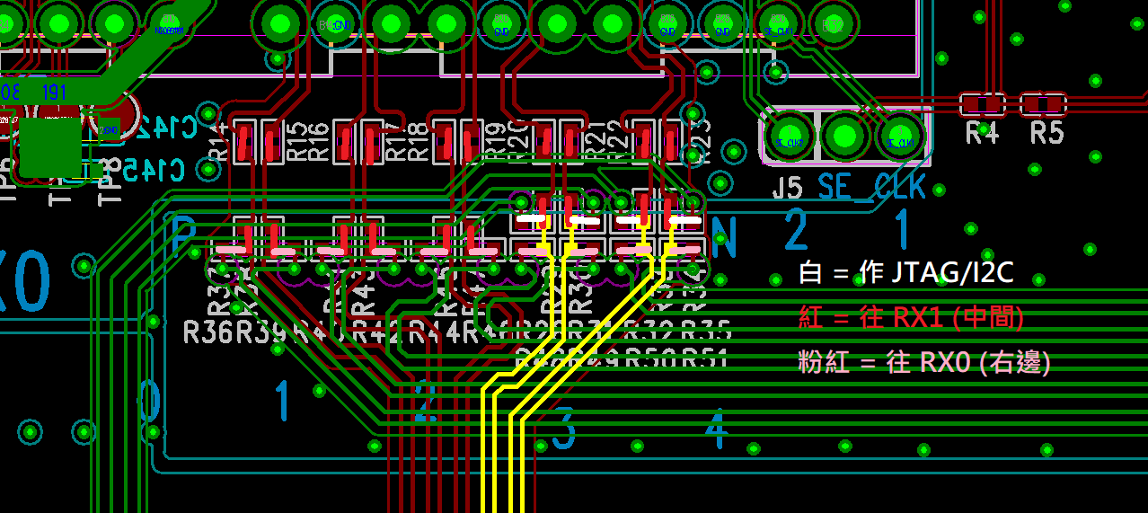

## SD Card Power Enable Polarity Switching

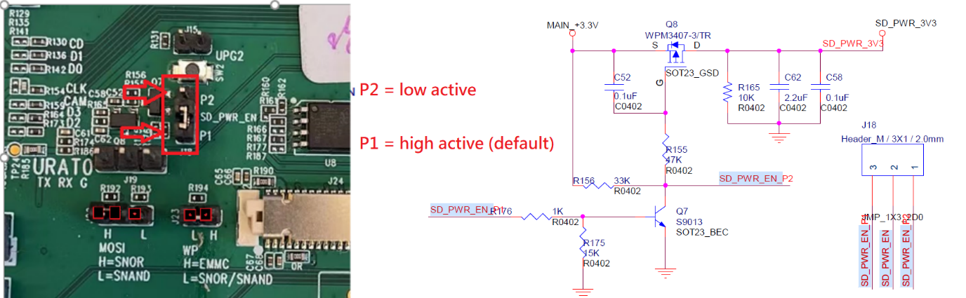

## VDDQ Voltage Switching

SG2002 and SG2000 are both DDR3L, VDDQ voltage requires 1.35V. (Jumper is 1.35V when unplugged, and it cannot be plugged in)

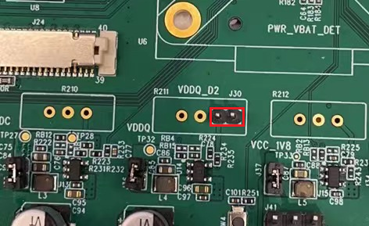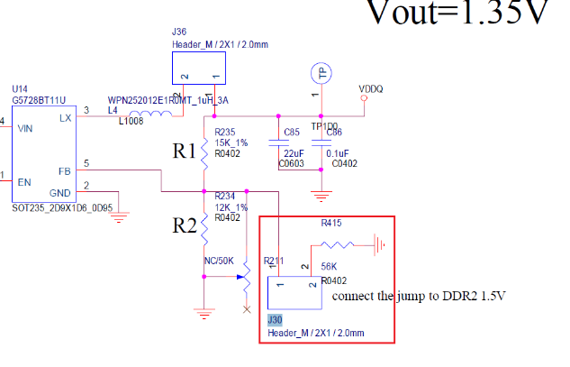

## Refer to the Jumper Connection

